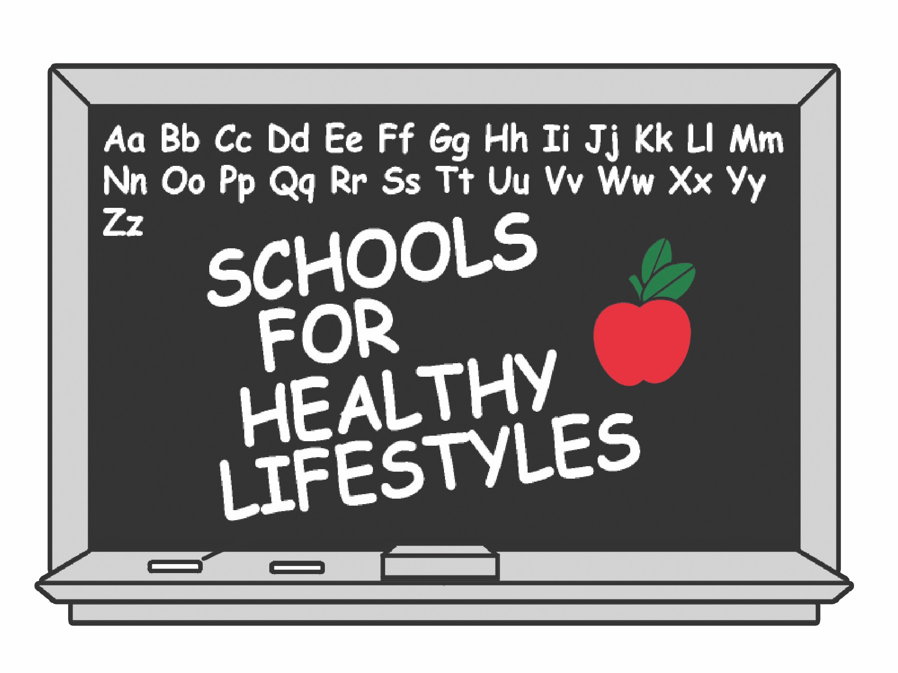
News
Release

For Immediate Release: Contact:
September XX, 2016 Lindsi Lemons
(405) 606-8435

Oklahoma City Schools Receive Awards at SHL Reception
Central, Coolidge and Tinker Elementary Schools recognized
at the Schools for Healthy Lifestyles Annual Awards Reception.

______________________________________________________________________________

Oklahoma City – Sixty-eight schools across the state are teaching students how to live a healthy lifestyle and make good choices regarding nutrition and fitness as part of Schools for Healthy Lifestyles.

Central Elementary, a Putnam City Public School; Coolidge Elementary, and Oklahoma City Public School; and Tinker Elementary, a Mid-Del Public School were recognized at the annual SHL awards reception.

- Central Elementary was awarded the Injury Prevention Award for their efforts to bring in outside resources to educate students about safety. They partnered with the Downtown Optimist Club to teach students about bicycle safety during the school year. This was a great way to make bicycle safety fun.

- Coolidge Elementary was given the Rookie of the Year Award for their ability to implement the SHL program during their first year. Coolidge jumped and completed the Let’s Move Active School process and participated in the Global Health Challenge. The were excited and willing to participate in the Tobacco Jingle Contest, the Brain Break Video Challenge, and their desire to look for creative ways to encourage healthy lifestyles.

- Tinker Elementary was awarded the Oral Health Education Award for their commitment to bring in an outside resource to educate students on proper dental hygiene habits. The
- more -

Page 2 (cont.) – OKC Schools Receive Top Awards

Tinker Air Force Base Dental Clinic came out and set up stations for three days to include all students. Tinker Elementary’s efforts to promote oral health and healthy dental habits made a difference in many students lives this year.

“All of our SHL schools work hard to make sure our students are learning how to live a healthy and safe lifestyle. The Awards Luncheon is a great way for us to recognize these hard working teachers for their diligence, creativity and commitment to our mission,” said Lindsi Lemons, SHL Program Director. “These Oklahoma City Schools have truly adopted the importance of health and wellness throughout the entire school.”

SHL is a not-for-profit organization formed in 1997 to combat Oklahoma’s declining health status. SHL’s mission is to promote and maintain healthy lifestyles among students, families and
educators. Its five focus areas include: physical activity and fitness; nutrition education and awareness; tobacco use prevention; safety and injury prevention; and oral health education.

SHL serves 68 elementary schools across the state and partners with more than 50 public and private health-related organizations to accomplish its mission. For questions or more information, please visit www.healthyschoolsok.org or contact the SHL office at 405-606-8435.

# # #

